Performance Evaluation of Ad-Hoc On-demand Distance Vector Routing Protocol Based On Metrics

Sparrow Platform
New York, USA
sparrowplatform@gmail.com

Abstract— In Ad hoc networks, communication takes place via a wireless infrastructure. The nodes in such a network are mobile and can act as routers. Therefore in such a network, protocols are needed which set up proficient routes among nodes. For this, many reactive, proactive and hybrid protocols have been proposed. Adhoc On-demand Distance vector routing (AODV) is one such popular protocol due to its high performance gain when compared to other protocols in Mobile Adhoc networks [3].
This paper evaluates the performance of AODV by making use of three metrics - end to end delay, packet delivery ratio and packet loss while varying the number of nodes in the network. The results of the simulation carried out in NS2 are also presented. The overview of how AODV works, its features, its benefits compared to others protocols are also provided. The impact of a malicious node in AODV and improvements to AODV are evaluated.
Keywords—AODV; Performance evaluation; Adhoc; NS2; DSDV; DSR;

Introduction
There are three major categories of routing protocols - proactive, reactive & hybrid. In proactive protocols, the topology of the network is continuously learned by exchanging information among the nodes in the network. Each node builds its own routing table and then uses it to find path to destination. The cost of maintaining the network will increase if this topology changes often. Destination-Sequenced Distance-Vector Routing (DSDV) [4] belongs to this category. However in the case of reactive routing, the nodes do not exchange any routing information. Whenever a node needs to send some data to destination node, it obtains the path to it dynamically. AODV [1, 2] and Dynamic Source Routing (DSR) [5] are some examples of this category. Hybrid routing protocols are a combination of both reactive and proactive protocols.

In order to realize the performance of any routing protocol quantitatively, various metrics like packet delivery ratio, end to end delay and packet loss need to be used. Simulation can be can be done by varying the number of nodes in the network in simulator NS2 [3].

Overview of aodv
AODV is useful when there is limited bandwidth in the medium is used for wireless communications. It is a combination of both DSR and DSDV. It uses the on-demand mechanism of route discovery as well as route maintenance from DSR, and hop-by-hop routing, periodic update packets and sequence numbers, from DSDV. The advantage of AODV over DSR is that the source route need not be included with every packet. Therefore, a reduction in the routing protocol overhead is obtained. However, AODV requires periodic updates which intern consumes more bandwidth than that which is saved by excluding source route information in the packets. A route is discovered through network wide broadcasting. The source host starts the route discovery by broadcasting a route request packet to all its neighbours. A route discovery process is initiated when a node wants to send a packet to some destination node but does not have a valid route in its routing table for that particular destination. The process is described in detail in the following sections.

Control Messages in AODV
The four control messages used by AODV are described below:

Routing Request (RREQ): A route request packet (RREQ) is flooded throughout the network when a route to the destination node is not available.

Routing Reply (RREP): If a node has a valid route to the destination, or if it itself is the detination, it unicasts a route reply message (RREP) back to the source node.

Route Error Message (RERR): This message is sent when:
• Destination is no longer reachable: A node finds that a link with its adjacent neighbour is broken.
• A node it gets a data packet which to be sent to a destination node. However it does not have an active route to that destination node.
• An RERROR is received from a neighbour when a link is lost. This is done to notify the other nodes on both sides of the link about loss of that link.

HELLO Messages : HELLO messages are local broadcast messages that are sent so that each node can get to know its neighborhood. These periodic HELLO messages are used by AODV to inform the neighbors’ that the link is still alive. The HELLO messages can never be forwarded because they are sent with a time to live value of one. As soon as a node receives a HELLO message, the information about lifetime in the routing table is refreshed.

Working of AODV
Whenever a node has data to send to some destination, it checks its routing table to see if it has a route to the destination. If a route exists, the packet is forwarded to the next hop node. If not, a route discovery process is initiated.

Route discovery: RREQ is broadcast to neighbours from the node for a particular destination. When an intermediate node receives a RREQ, it checks its routing table. If a route is found, a RREP (reply) is sent to the source. If a route is not found, RREQ is rebroadcast to neighbours and a reverse route path to source node is set up in the routing table. RREQ is ignored if processed already. Finally when RREQ reaches the destination node, it unicasts RREP to the source node by using the reverse route set up to the source node.

Route Maintenance: Active nodes in the network broadcast a HELLO message periodically. If there is no HELLO message received from a neighbour, an RERR is sent to the source and all routes based on the node are invalidated. new route discovery stage and flood the RREQ packet.

Evaluation Metrics
We have evaluated the performance of AODV protocol by the quantitative study of values of different metrics which are as follows

Average End-to-End Delay
Definition: The average time taken by data packets to propagate from the source to the destination across a mobile Ad-hoc network.
This includes propagation time, transfer time, delays caused by buffering during routing, discovery latency, and retransmission delays. The performance of a protocol is said to be better if the value of the end-to-end delay is less [6].

End-to-End delay = Σ (Time of packet arrival - Time of packet sending)

Packet Delivery Ratio
Definition: The ratio of the number of packets received by the destination to the number of packets sent by the source. This illustrates how much data is sent to the destination. The performance of a protocol is said to be better if the value of PDR is large.

PDR = Σ Number of packets received / Σ Number of packets sent

Packet Loss
Definition: Number of packets dropped by nodes. The performance of a protocol is said to be better if packets lost are less [3]

Packet loss = Number of packets sent – Number of packets received.

SIMULATION
For simulation of AODV, DSR and DSDV, the Network Simulator 2(NS2) has been used.

Sr.No. | Parameter | Value
1 | Simulator | NS-2 (Version 2.34 )
2 | Channel type | Wireless Channel
6 | Simulation Time | 500 sec
7 | No of Nodes | 10-50
8 | Routing Protocol | AODV

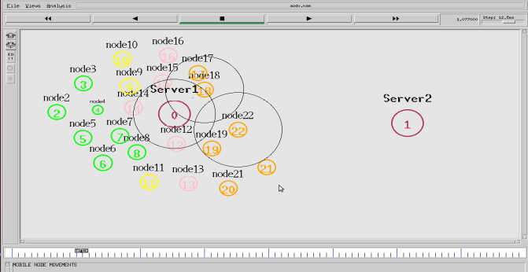
Fig. 1 AODV simulation

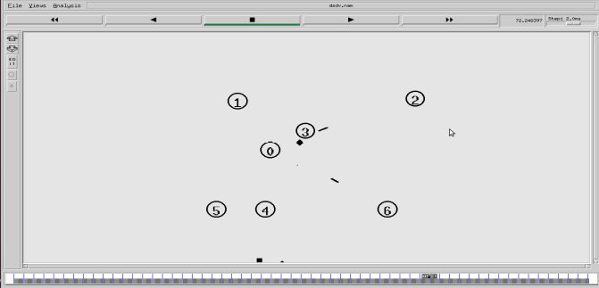
Fig. 2 DSDV simulation

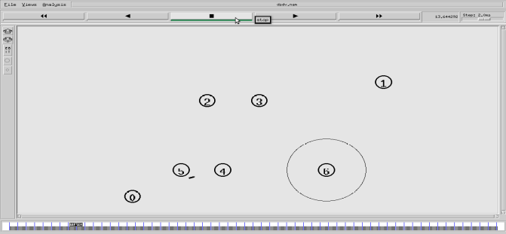
Fig. 3 DSR simulation

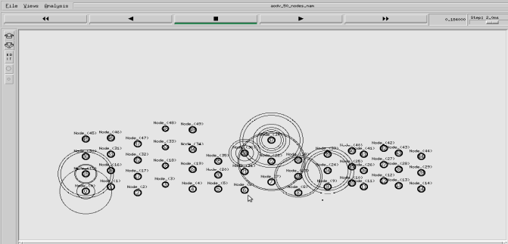
Fig. 3 AODV 50 nodes simulation

Results and Analysis

Packet Delivery Ratio

Sr. No. | No of Nodes | PDR | Packets | Packets
 |  |  | Sent | Received
1 | 10 | 0.93 | 4892 | 4569
2 | 20 | 0.94 | 4892 | 4607
3 | 30 | 0.94 | 4892 | 4618
4 | 40 | 0.9 | 4892 | 4406
5 | 50 | 0.89 | 4892 | 4379

Analysis:

Initially PDR increased, but overall PDR decreased as the number of nodes increased. This is because as the packets move from source to destination, collision between packets occurs due to traffic. This causes loss of packets. Also, the mobility of nodes may make the nodes move out of network and thus the packets do not reach the desired node.
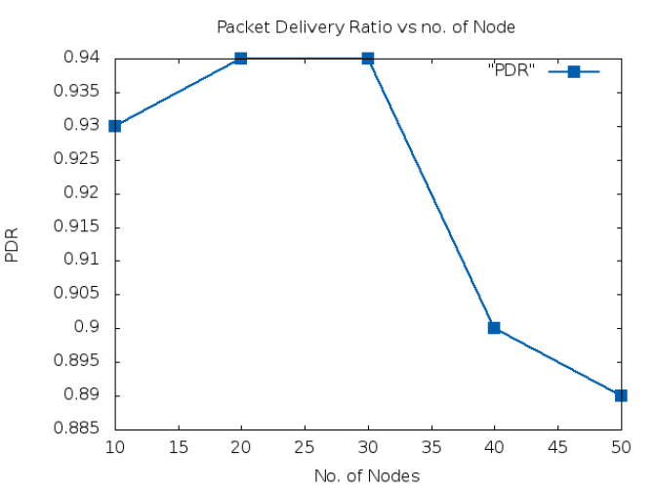

Average End-to-End Delay

Sr.No. | No. of Nodes | End to End Delay (ms)
1 | 10 | 92.57
2 | 20 | 92.88
3 | 30 | 92.87
4 | 40 | 93.00
5 | 50 | 93.02

Analysis:

Average End-to-End delay increases with the increase in the number of nodes. Besides the actual delivery of data packets, the delay time is also affected by route discovery, which is the first step to begin a communication session. Hence, while source routing makes route discovery more profitable, it slows down the transmission of packets.

Packet Loss

Sr. No. | No of Nodes | Packets Lost | Packets | Packets
 |  |  | Sent | Received
1 | 10 | 323 | 4892 | 4569
2 | 20 | 285 | 4892 | 4607
3 | 30 | 274 | 4892 | 4618
4 | 40 | 486 | 4892 | 4406
5 | 50 | 513 | 4892 | 4379

Analysis:

Packet loss increases with the increase in number of nodes. At higher loads, number of false route breaks increases due to congestion created by more number of active sessions. False route breaks occur as nodes falsely assume that a route break has occurred, when there are lots of packet drop because of collisions created by congestion. Moreover, since the topology keeps on changing in AODV network there is possibility of losing the packet as nodes get displaced from their previous position.

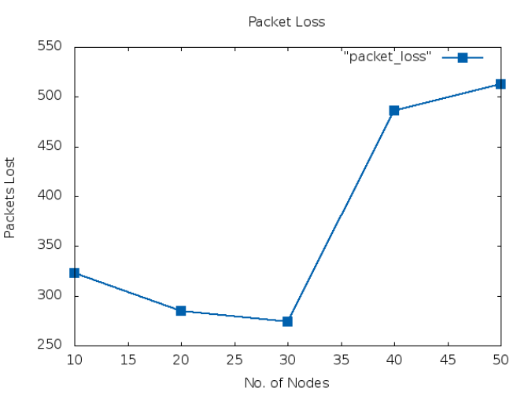

Extension Of Aodv

AODV protocol is extended with a drop factor that introduces a randomness feature to result in Randomized Ad-Hoc On-Demand Routing (R-AODV) protocol.

Algorithm:
Step 1: Calculate drop factor
Drop factor = (1 / (Hop count of RREQ packet + 1))

Step 2: Calculate a random value in the range of 0 to 1.

Step3: If (random value > drop factor) then broadcast/forward RREQ packet else drop RREQ packet. Thus in r-AODV, RREQ packet is not forwarded in all cases but randomly to try to reduce congestion caused by these unnecessary redundant packets.

Results:
AODV simulation:
Throughput = 0.67
Sent Packets = 8343
Received Packets = 5594
Total Dropped Packets = 2749
Average End-to-End Delay = 18.3458ms

r-AODV simulation:
Throughput = 0.72
Sent Packets = 6667
Received Packets = 4826
Total Dropped Packets = 1841
Average End-to-End Delay = 12.6981ms

Analysis:
It can be seen that the ratio of the number of packets received by the nodes to the number of packets sent by the nodes, namely, throughput, should is higher in R-AODV compared to AODV. This is because in R-AODV, the dropping of redundant RREQ packets reduces a proportion of RREQ packets that shall never reach the destination node, resulting in a decrease of network congestion.

Aodv Comparison With DSR and DSDV
Dynamic Source Routing (DSR) is similar to AODV in that it forms a route on-demand when a transmitting node requests one. However, it uses source routing instead of relying on the routing table at each intermediate device.
Determining source routes requires accumulating the address of each device between the source and destination during route discovery. The accumulated path information is cached by nodes processing the route discovery packets. The learned paths are used to route packets. To accomplish source routing, the routed packets contain the address of each device the packet will traverse. This may result in high overhead for long paths or large addresses.

Disadvantages:
1. The route maintenance mechanism does not locally repair a broken link.
2. The connection setup delay is higher than in table-driven protocols
3. The performance degrades rapidly with increasing mobility.
4. Considerable routing overhead is involved due to the source-routing mechanism employed in DSR. This routing overhead is directly proportional to the path length.

Analysis:

AODV exhibits a better performance in terms of packet delivery fraction and throughput with increasing number of mobile nodes due to its on demand characteristics to determine the freshness of the routes.

- AODV has slightly higher average end-to-end delay than DSR.

- AODV performs well with varying network size.

Conclusion
Thus we have evaluated the performance of on demand routing protocol AODV, by means of various performance metrics such as PDR, end to end delay & packet loss, as well obtained simulation results by varying number of nodes in the network.
We have also explored how AODV can be improved by introducing randomness feature and the effects of malicious node in AODV.
Also, comparing with DSR or DSDV, AODV performs better with varying network size.

References

- C. E. Perkins and E. M. Royer, “The Ad hoc On-Demand Distance Vector Protocol,” in Ad hoc Networking, C. E. Perkins, Ed. Addison-Wesley, 2000, pp. 173–219
- C. E. Perkins, E. M. Belding-Royer, and S. Das, “Ad hoc On-Demand Distance Vector (AODV) Routing,” RFC 3561, July 2003
- Laxmi Shrivastava, Sarita S.Bhadauria, G.S.Tomar, ‘Performance Evaluation of Routing Protocols in MANET with different traffic loads’, International Conference on Communication System Network Technologies IEEE 2011.
- C.E. Perkins and P. Bhagwat, “Highly dynamic destination-sequenced distance vector routing (DSDV) for mobile computers,” in Proc. ACM SIGCOMM 94, London, UK, Oct. 1994, pp. 234-244.
- David B. Johnson, David A. Maltz, Yih-Chun Hu and Jorjeta G. Jetcheva, "The dynamic source routing protocol for mobile ad hoc networks", Internet Draft MANET Working Group, February 2002.
- Vijayalakshmi M. & Avinash Patel ,” Qos Parameter Analysis On Aodv And Dsdv Protocols In A Wireless Network”, Vijayalakshmi M.Indian Journal of Computer Science and Engineering Vol. 1 No. 4 283-294.
- A. Tuteja, R. Gujral and S. Thalia, "Comparative Performance Analysis of DSDV, AODV and DSR Routing Protocols in MANET Using NS2," Advances in Computer Engineering (ACE), 2010 International Conference on, Bangalore, Karnataka, India, 2010, pp. 330-333.

